Christmas

On 25 December, Great Britain and the United States (and many other countries) Celebrate Christmas. The word Christmas comes from the Old English “Cristes maesse”. Christ´s mass. On this day, Christians celebrate the birth of Christ.

Kindness and giving are the spirit of Christmas. Charles Dickens, the famous British writer, wrote *A Christmas Carol*, a story about the meaning of Christmas.

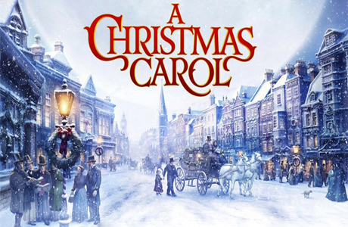

Why is Christmas celebrated on 25 December?

Christmas comes from two pagan festivals. People celebrated the winter solstice on 21 or 22 December. The Roman emperors chose 25 December as the birthday of the sun (natalis solis).

After the winter solstice, the days become longer and the sun is higher in the sky. In ancient Rome, this was the season of Saturnalia. Saturnalia was a time of enjoyment and fun. During Saturnalia the Romans exchanged presents.

The pagan tribes of northern Europe enjoyed a 12-day winter festival called Yule. Yule had its own traditions of Yule cakes, fir trees, holy mistletoe and presents. Fir trees and holly mistletoes are still a symbol of Christmas. Today a branch of mistletoe in the house has another meaning: when a boy and girl meet under the mistletoe they usually kiss! The custom of kissing under the mistletoe is an ancient Celtic rite.

Medieval Christmas was a long event. It lasted twelve days like the Yule festival. Celebrations started on 25 December and ended on the night of 6 January.

Christmas is the biggest holiday on the American and British calendar. However, in Scotland, New Year is more important. I Great Britain and the United States people prepare for Christmas weeks before 25 December.

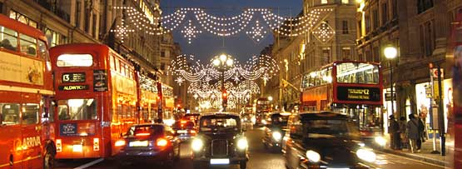

Cities and towns are beautifully decorated with Christmas symbols: the Christmas tree, Santa Claus, colourful lights and much more. Shop window are full of presents for everyone. People are busy buying presents. There are Santa Clauses everywhere. On street corners people sing Christmas carols. In Britain, many children go carol singing with an adult. They go from house to house and sing. They usually receive money for their singing. They use this money to buy presents. There is a joyous atmosphere.

The modern Christmas tree originated in western Germany long ago. The Germans put up a fir tree in their homes and decorated it with biscuits and candles. German settlers took this tradition to North America in the 17th century. By the 19th century Christmas trees were very popular in the United States.



In Britain, the Christmas tree became popular after 1840. The German Prince Albert, Queen Victoria´s husband, took the Christmas tree to the British Royal Family. Soon the Christmas tree became popular all over Great Britain. There is a big tree every year in Trafalgar Square, London.

Today´s America´s most famous Christmas tree is in the Rockefeller Center, New York City.

The Empire State Building in New York City is one of the tallest buildings in the world. At Christmas, the top of the building is illuminated with red and green lights!

Today almost every Christian family has a decorated Christmas tree at home or in the garden. Some families put up the tree on Christmas Eve and others put it up at the beginning of December. Many families put a Nativity scene under the Christmas tree. St. Francis of Assisi created the first Nativity scene in the 1200´s!

Many Americans wear “Christmas clothes” during the Christmas season. These are clothes with Christmas colours and symbols.

Christmas crackers are and old tradition. They were invented in London. Two people pull the cracker until it “bangs” and opens. Inside there is usually a small present, a paper hat and a joke.

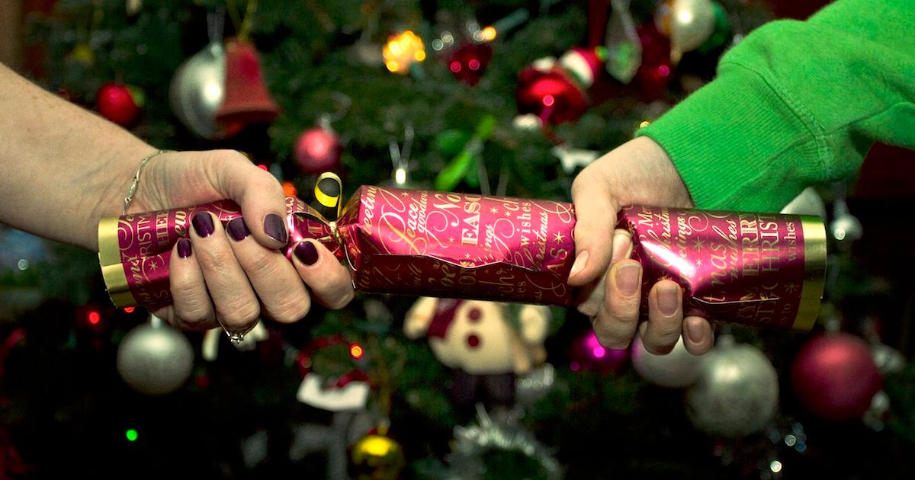

In the United States there are “Christmas shops” in many cities. They sell all types of Christmas trees, ornaments and other decorations for the home. “Christmas shops” are open all year long, so you can buy your Christmas tree in June!

It is usual to send Christmas cards to relatives and friends. The first Christmas card was designed by John Callcott Horsley in 1843. A thousand copies of the card were printed in London. The design was a family party with the words “A Merry Christmas and a Happy New Year to you.”

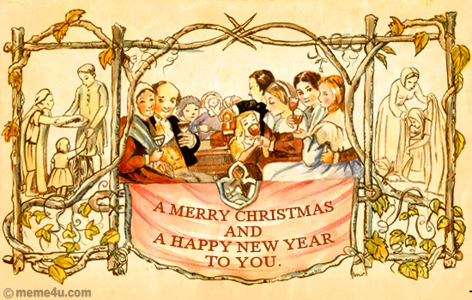

In the mid-19th century a shop owner in Albany, New York, made a card that said, “Christmas Greetings from Pease´s Great Variety Store.” This was the beginning of the big Christmas card industry.

|  |  |
| --- | --- |
| Resultat d'imatges de santa claus vintage images | The figure of Santa Claus comes from St. Nicholas, a 4th century Christian bishop of Asia Minor. He was famous for his generosity and kindness. The Dutch settlers of New York brought the tradition of Sinterklaas (Santa Claus) to America.  Father Christmas, or Santa Claus, is an important part of the Christmas tradition. Children write letters to him and ask for special presents.  Today we see Santa Claus as an old man with white beard, dressed in a red suit. He drives a sleigh pulled by reindeer and comes down the chimney with toys for the children. This image of Santa Claus was created by American cartoonist Thomas Nast in 1863. |
|  |  |

American and British children put out a stocking on Christmas Eve because they hope to receive presents from Santa Claus. Then they go to bed early because they want Santa Claus to come. Many Christians go to church services at midnight and others go on Christmas morning. Christmas presents are usually opened on Christmas morning. After Christmas dinner many families listen to the traditional Queen´s Speech in Britain and watch special television programmes. Children play with their new toys.

In Britain some people go for a Christmas Day swim in the sea or in a lake. In Hyde Park in London some courageous people swim in the Serpentine!

