A GREENER FUTURE

READING COMPREHENSION
- Read the following text about green transport. How is 3D Express Coach good for the environment?
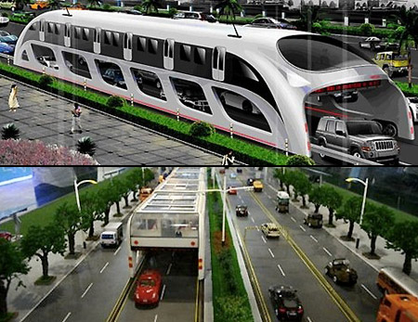
The 3D Express Coach

Cars cause air pollution. It´s a simple fact. If more people drive cars, pollution will increase. If fewer people drive cars, the air will be cleaner. So, what do you do in a huge country like China? China has got the largest population in the world. It has got 120 large cities with more than a million people in each one. There are already about 200 million cars, lorries, buses and motorbikes on the roads in China. If its population grows according to experts´ predictions, the number of vehicles there will increase to about a billion by the year 2050. The effect on air pollution will be disastrous.

Electric vehicles are one possible solution to this problem, and China already produces millions of electric bicycles. But electric bikes can´t replace public transport like trains and buses. In order to do that, you need the 3D Express Coach. What is it? It is a giant bus. It runs on electric and solar power, and it travels over traffic, not in it.

Shenzhen Hashi future Parking Equipment had the idea for this amazing invention, and they´re going to start building it soon. The 3D Express coach will be 6 metres wide and 4,5 metres tall, and it´ll have room for more than a thousand people! According to the director of Shenzhen, it will save up to 860 tons of fuel a year.

- What do the following numbers refer to?

- 120:
- 200 million:
- 6:
- 4,5:
- 860:

- Which questions does the text answers? Answer those questions.
- What is the population of China today?

- How many vehicles do experts think the Chinese will drive by the year 2050?

- What type of electric vehicle do the Chinese make now?

- Where does the 3D Express Coach drive?

- Which company designed the ·D Express Coach?

- When will the 3D Express Coach start transporting passengers?

- Look at the chart. Why is the 3D Express Coach better than the London double-decked bus? Give three reasons.

THE 3D ESPRESS COACH
Vs
THE LONDON DOUBLE-DECKER BUS
3D EXPRESS COACH | LONDON DOUBLE-DECKER BUS
Passengers: 1,400 | Passengers: 128
Speed: 60 km/hour | Speed: 15 km/hour
Fuel: Electricity and solar power | Fuel: Diesel
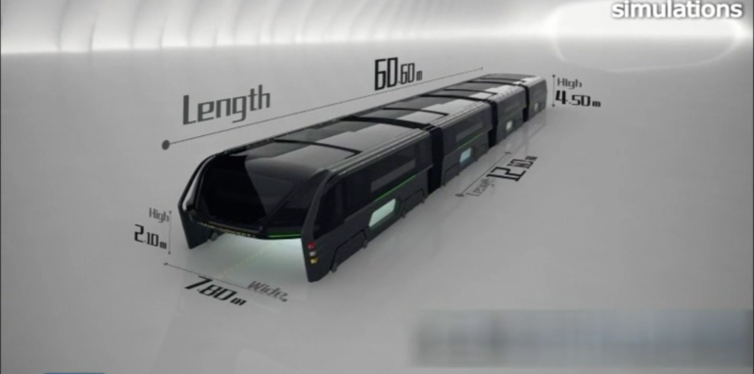 | 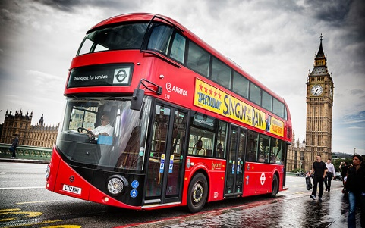

VOCABULARY
- Find words in the text to match the definitions below.

- Become bigger than before (lines 1-5)
- Extremely bad (lines 6-10)
- Be a substitute for (lines 11-15)
- Energy from the sun (lines 11-15)
- How fast something moves (chart)

- a. A text often includes synonyms instead of repeating the same word. How many synonyms for the word big can you find in the text?

b. In the text you can find many other adjectives. Can you write them down?

GRAMMAR
FIRST CONDITIONAL

When we discuss the future, we often use the First Conditional to talk about a possible result that depends on a specific situation or condition.

If many people drive cars, pollution will increase.
The Earth will be cleaner if everyone respects the environment.



First Conditional link: http://www.aprenderinglesrapidoyfacil.com/2014/04/22/primer-condicional-ingles-explicacion-first-conditional/

- Complete the sentences with the verbs in brackets. Use the First Conditional. Which sentences do you think are true and which do you think are false? Could you correct the false ones?
- If your friend ₁ (throw) a plastic bag on the ground, it ₂ (decompose) in a month or two.
- If you ₃ (buy) fewer electric appliances and mobile phones, you ₄ (help) the environment.
- Polar bears ₅ (not have) homes if the climate ₆ (become) warmer.
- If your mum ₇ (drive) her car at a slower speed, it ₈ (produce) less carbon.
- The air ₉ (be) cleaner if we ₁₀ (cut down) trees.

- Sam wants his family to be more environmental friendly. Match each action to its result. Then write sentences in the First Conditional using the words in brackets.
ACTION | RESULT
- heat food in the microwave  (everyone in the family) | - save trees
- read newspapers online  (Dad) | - save time and electricity
- use electric vehicles  (Mum and Dad) | - create less rubbish
- not use plastic bags  (everyone in the family) | - save water
- use the dishwasher  (I) | e. produce less carbon

- If everyone in the family heats food in the microwave, they´ll save time and electricity.

- Can you write two more sentences using the First Conditional?

