

New Year´s Day

Happy New Year!´

´The same to you and many more.´ This familiar greeting is heard throughout Britain and the United States on 1 January.

People have always celebrated the New Year. In ancient civilizations the calendar was based on the seasons. The Egyptian New Year began when the Nile River overflowed. For the early Britons and the Romans the New Year began on the first day of spring.

In 45 BC the Roman Emperor Julius Caesar created a calendar with 1 January as the first day of the new year. This calendar is still used today. January comes from ´Janus,´ the Roman god of beginnings and endings.

New Year´s traditions come from different cultures. Many people give presents and send cards on New Year´s Day. This was part of a Roman and old English tradition. Shops and offices give calendars and small presents to their clients.

In Britain most families have a big lunch and spend a quiet day at home.

In the United States many families have ´Open House´ on New Year´s Day. It is a custom introduced by George Washington, the first President of the United States. During ´Open House´ the front door of your home is open all day long. Friends and relatives come to say ´Happy New Year!´ They eat and drink something and then leave. Many clubs and organisations have ´Open House´ too.

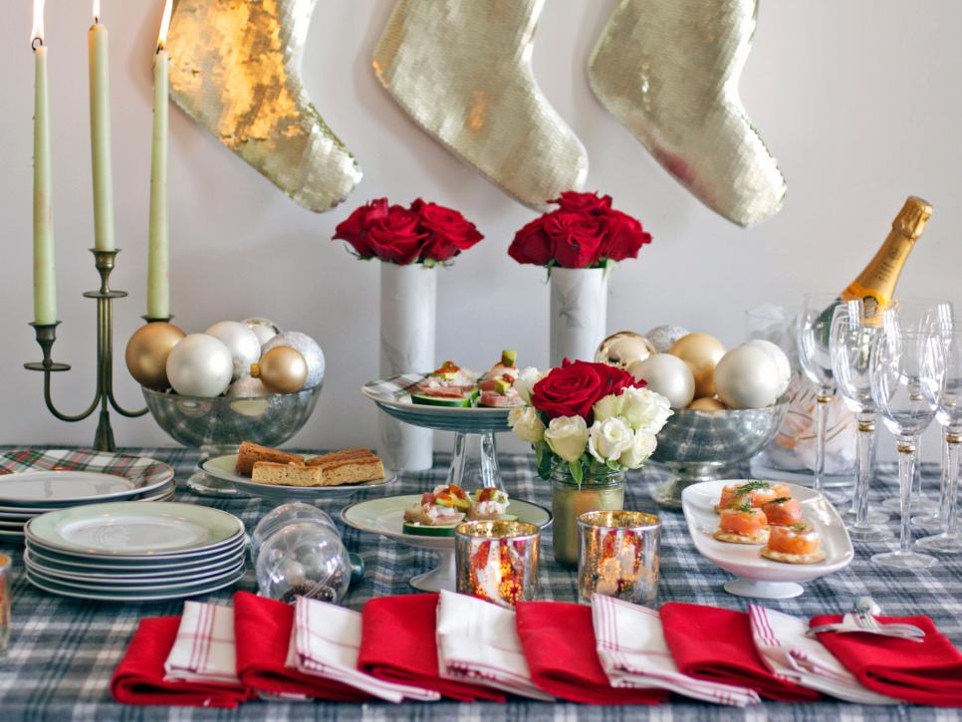

On New Year´s Day most of the United States is covered with snow. However, in California and in the southern states it is warm and sunny. In these sunny places there are parades and football games. These football games are called Bowl Games. Each region has its parade and football game.



The Pasadena ¨Tournament of Roses´ parade is the biggest and oldest New Year´s Day event. In Pasadena more than three million people go to watch the parade! More than 70 million Americans watch it on television.

Every year there are about 60 spectacular floats made of fresh flowers. The floats shiw favourite storybook characters and animals. The queen of the parade is called the Citrus Queen, because so many citrus fruits grow in southern California.

It takes about a year to organize the Pasadena ´Tournament of Roses´ parade! The entire city participates in this extraordinary event.

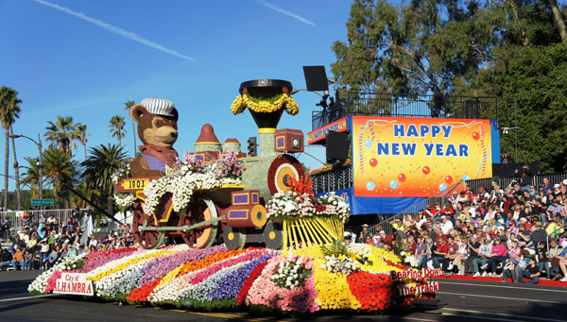

When the parade ends everyone goes to the football stadium to watch the Rose Bowl Game, the biggest sports event of the year.

Another famous New Year´s Day parade is the Macy´s Day Parade in New York City. Many Americans watch this parade on television in the morning and in the afternoon they watch a football game.

UNDERSTANDING THE TEXT

Are the following sentences true or false? Correct the false ones.

1. People started celebrating the New Year in 45 BC.
2. The Roman Emperor Julius Caesar created a calendar with I January as the first day of the year.
3. In Britain many families have ´Open House´ on New Year´s Day.
4. In California and in the southern states it is warm and sunny in winter.
5. The Pasadena ´Tournament of Roses´ is an important football game.
6. The Rose Bowl game is the biggest sports event of the year.

ADJECTIVES

1. Let´s review the comparative and superlative forms of the adjectives. Can you complete the table?

|  |  |  |
| --- | --- | --- |
| ADJECTIVE | COMPARATIVE | SUPERLATIVE |
| young |  |  |
| small |  |  |
| rich |  |  |
| cold |  |  |
| easy |  |  |
| noisy |  |  |
| sunny |  |  |
| bad |  |  |
| good |  |  |

1. Fill in the gaps with the correct superlative form from the table:
2. New Year´s Eve is noisy. It´s the ……………………. Night of the year.
3. California is a sunny place. It´s the ……………………….. place in America.
4. There were many young children in the parade, but John was the ……………………
5. A lot of Romans were rich, but Emperor Julius Caesar was the ………………………
6. Winter is the ………………………….. season of the year.
7. The biggest float won the prize because it was the ………………………….

Can you add two more sentences using the superlative form of the adjectives?

-

-

1. Now, can you write 8 sentences using the comparative form of the adjectives in exercise 1?