SPORTS

Can you match the sport with its correct name? Can you also describe the pictures and the sports they show?

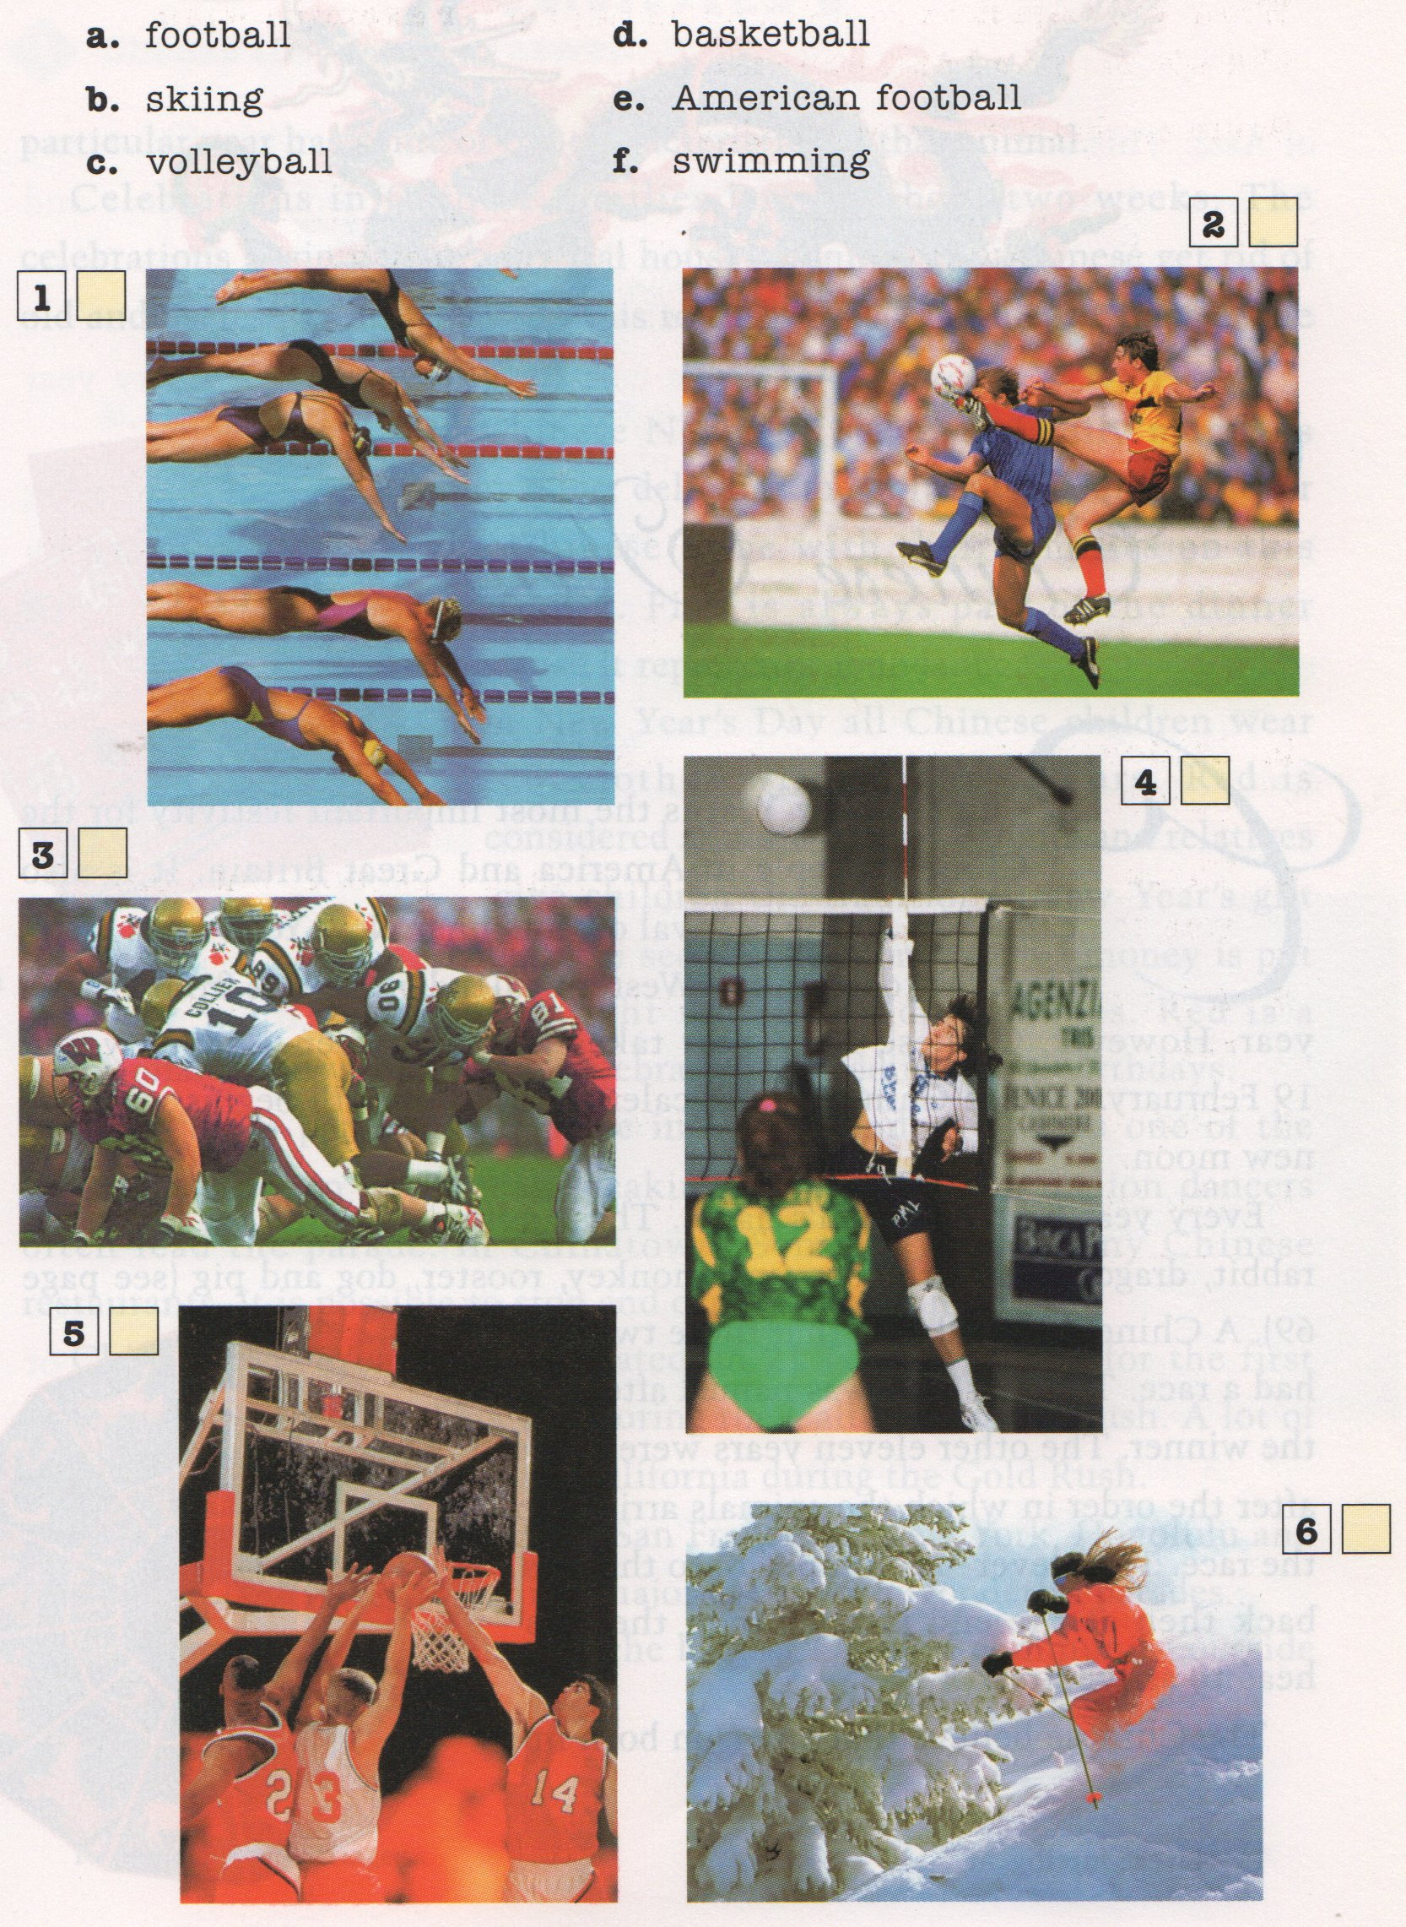

Picture 1:

Picture 2:

Picture 3:

Picture 4:

Picture 5:

Picture 6:

Some help...

<https://quizlet.com/13037837/adjectives-to-describe-sports-unit-2-flash-cards/>

<https://en.islcollective.com/resources/printables/worksheets_doc_docx/sports_description/sports-elementary-a1/41644>

<https://s-media-cache-ak0.pinimg.com/736x/ab/94/0d/ab940d3c05430c8b7285c723681b938d.jpg>